工業用電動起重車、堆高車及搬運車驗證市場分析報告
- 工業用電動起重車、堆高車及搬運車使用重要零件如下:
1) 電池
2) 馬達/馬達控制器/剎車
3) 電路控制與其零件(開關/燈/線材)
- 美洲UL電動車市場驗證分析
1) 驗證要求UL583內容要求,參照3.)
2) 個別零件要執行UL相關標準驗證
a.) 鋰電池必須符合Electric Vehicles, UL 2580 或Light Electric
Vehicle (LEV) UL 2271.
b.) 馬達/馬達控制器須符合Rotating Electrical Machines –
General Requirements, UL 1004-1.
c.) 個別零件若未申請UL,必須得由最終產品Lift Truck驗證者吸收
3.) 工廠現場執行目擊整機測試:
a.) 安全重要零件、外殼與材料,須適合使用.
b.) 報價未含差旅與食宿費
c.) 報價未含相關其他國家安規證書.
d.) 不得使用替代品(No alternate components are employed)
e.) Each line item above is a separate phase of the Service(s) and
is optional and independent of the completion of the previous phase(s). Your written acceptance will be required to proceed to the next phase(s) of the Service(s) and each phase will be governed by this Quotation and the referenced terms and conditions. Final certification, if applicable, is contingent on the successful completion of all phases and compliance with UL Requirements.
f.) This Quote anticipates that all requested information and/or samples necessary to proceed with the evaluation will be available within 60 days from the time they have been requested.
g.) This Quote includes the cost of a predetermined set of testing.
In the event of testing nonconformance, a summary of the testing results and cost for the additional evaluation will be provided. A separate project may be issued to cover the retesting.
h.) Additional cost will be required for any change of scope and/or rework, once the project is established.
i.) During the course of the evaluation, if requested information and/or samples are unavailable for more than 60 days, preventing work from continuing, we will close the project and bill for the charges incurred. A new project will be established when all necessary items are available.
j.) This quotation includes representative testing in order to provide a lower project cost limit and reduce sample requirements. Upon completion of the Phase 1 – Construction Review/Pre-Testing, if it is determined additional testing is required, additional costs may be necessary.
k.) Where testing is conducted at Lab outside UL, the client is required to cover the charges for Lab either on their own or as an additional charge above the cost limit.
l.) This quote excludes costs or fees associated with services of outside contractors or test facilities and certain special equipment charges. Completion time assumes that the outside contractor and test facilities, when necessary, will be available within the timeframe allotted.
m.) In accordance with UL's Data Acceptance Program (DAP), UL retains the right to request that a test or test program be repeated at UL or under UL witness after review of submitted data. Additional charges may apply.
All test equipment utilized during a factory visit that is provided by the client must have the proper calibration certificates submitted for review and verified for compliance prior to the arrival of the project handler.

Devices or materials utilized for testing and/or certification must be UL Certified and bear the appropriate UL Mark, while meeting the requirements outlined in the product standard being used for this evaluation. Any device or material that does not conform to these requirements may be subject to additional evaluation, prior to being utilized for testing in this project.

n.) Assumes the client can provide a sample(s) of each (Model AC F2-T Series & AC F2-D Series) unit for evaluation purposes.

Assumes the client can provide electrical schematics, voltage maps, and printed wiring board layout drawings (in English).

Assumes the client can provide adequate samples to complete all testing required at client's site.

Assumes the client can provided the necessary connections to allow us to function the controller as it is intended in the end use application.
o.) Assumes the client can provide a sample(s) of each (Model AC
Assumes the following tests to be conducted:
1.) Input Test – Components（Conduct both at DC and AC application)
2.) Temperature Test - Components（Conduct both at DC and AC application)
3.) Dielectric Withstand Test – Components
4.) Solid State Circuitry Test
5.) Low-voltage Limited Energy Circuit Measurements
6.) Ball Impact Tests
7.) Mold Stress Relief Test

Assumes we will test a model from the AC F2-T Series and a model from the AC F2-D Series to represent all models.

Assumes Model AC F2-T 48-240-240 will be tested and used to represent the AC F2-T (Pump) Series.

Assumes Model AC F2-D 48-240 will be tested and used to represent the AC F2-D (Traction) Series.

Assumes no unlisted component evaluations.

- 歐洲電動車市場驗證分析(參見:附件二)
1) 引用最終產品Lift Truck或Forklift機械指令2006/42/EC危險機械類Annex IV執行驗證,使用規範,可能包括:
A. 歐盟安規
a.) EN 12100：2010
Safety of machinery - General principles for design - Risk
assessment and risk reduction
b.) ISO 13849-1 :2015
Safety of machinery — Safety- related parts of control systems Part 1: General principles for design
IEC Guide 115 2007
Application of uncertainty of measurement to conformity
assessment activities in the electrotechnical sector
c.) IEC 61508-1:2010
Functional safety of electrical/electronic/programmable
electronic safety-related systems - Part 1: General requirements
d.) IEC 61508-2:2010
Functional safety of electrical/electronic/programmable
electronic safety-related systems - Part 2: Requirements for
electrical/electronic/programmable electronic safety-related
systems.
e.) IEC 61508-3:2010
Functional safety of electrical/electronic/programmable electronic safety-related systems - Part 3: Software requirements
f.) IEC 61508-4:2010
Functional safety of electrical/electronic/programmable electronic safety-related systems - Part 4: Definitions and abbreviations.
g.) IEC 62061:2015:
Safety of machinery - Functional safety of safety-related electrical, electronic and programmable electronic control systems
h.) EN 61800-5-1:2007+A1:2017
Adjustable speed electrical power drive systems —Part 5-1: Safety requirements —Electrical, thermal and energy
i.) EN 61800-5-2:2017
Adjustable speed electrical power drive systems. Safety requirements. Functional
j.) EN1175-1:1998+A1:2010
Safety of industrial trucks-Electrical requirements-Part 1: General requirements for battery powered trucks
k.) EN280:2013
Mobile elevating work platforms-Design calculations- Stability criteria - Construction - Safety- Examinations and tests.
l.) IEC 60204-1:2016
Safety of machinery - Electrical equipment of machines –
Part 1: General requirements
B. 歐盟EMC電磁相容
a.)EN 61800-3:2018
Adjustable speed electrical power drive systems. EMC requirements and specific test methods
b.)EN12895:2015
Industrial Trucks- Electromagnetic compatibility
c. EN61000-6-2:2016
Electromagnetic compatibility (EMC) - Part 6-2: Generic standards - Immunity standard for industrial environments
d. EN61000-6-4:2018
Industrial Trucks- Electromagnetic compatibility
2.) 個別零件要執行CE電動車相關標準驗證
a.) 鋰電池48V ac必須符合: RoHS及 Reach
b.) 馬達31V ac必須符合 : RoHS及 Reach
c.) 48V ac馬達控制器,須引用最終產品Lift Truck 及
Forklift危險機械類2006/42/EC機械指令,Annex IV執行驗證,可能
引用標準,如上述1.)所述
3.) 工廠現場執行目擊整機測試
必須根據2006/42/EC危險機械類Annex IV執行驗證測試

- 實務驗證
A.必須備妥所有相關元件安規證書或執行個別元件驗證
B.必須備妥所有測試設備進行目擊現場測試
C.Lift truck 或 Forklift等成品驗證必須個別獨立執行測試驗證
- 結論
A.此項工程浩大, 牽涉包括: 時間、金錢及相關供應鏈產業.
B.台灣相關供應鏈產業,相對落後於中國、日本、義大利、加拿大及韓國,
必須利用最終成品驗證機會,同時加入相關供應鏈產品,方可有機會節省
驗證成本並在最短的時間內趕上工業用電動產業的熱潮
C.以Lift truck 或 Forklift最終成品製造廠商、Motor Controller或
馬達廠為中心,聯繫相關供應鏈業者,成立一專業實驗室執行驗證測試
參考:
附件一: UL 驗證美洲市場分析
附件二:歐洲TUV萊茵驗證市場分析

撰文: 楊安遠 2021/3/9
賽澳紐企業有限公司
台中市大里區永興路 232 巷 35 號 412
E-Mail: ever.safety@hotmail.com
Tel: 886-4-2482-0551/886-0913-562-022

附件一
UL 驗證美洲市場分析
- Category code: YCFT2 (Motor Controller)
YCFT2 Industrial Truck Accessories, Battery Powered - Component市場概況
USA | Italy | Japan | Mexico | Netherland | Korea | Sweden | China
59 | 12 | 4 | 3 | 2 | 6 | 2 | 5
Germany | Canada | Czech | Finland | France | India | Taiwan
6 | 3 | 1 | 1 | 1 | 1 | 2
Japan: Toyota/Mitubishi: Motor controller
Mexico: Motor
Korea: DC Converter/AC motor/Steering Controller
Sweeden: Vehicle master controller
- 最終產品
    - XWJV :Trucks, Electric-battery-powered) Trucks, Industrial, Type E: 22家
USA | Italy | Canada | Korea | China
15 | 1 | 2 | 3 | 1
    - XWXT :Trucks, Electric-battery-powered) Trucks, Industrial, Type EE 24家
USA | Italy | Canada | Korea | China | Japan
16 | 1 | 2 | 3 | 1 | 1
    - XVVX: This category covers electric-battery-powered industrial trucks classed as Types E, CGH, E or CGH, EE or ES. 0家
Types of industrial trucks have been certified only as to fire and electric shock hazards for use in locations defined in ANSI/NFPA 505, "Fire Safety Standard for Powered Industrial Trucks Including Type Designations, Areas of Use, Conversions, Maintenance, and Operations."
Unless marked to indicate otherwise, industrial trucks are tested on a course having a ramp with a 5% minimum grade.

附件二
歐洲TUV萊茵驗證市場分析
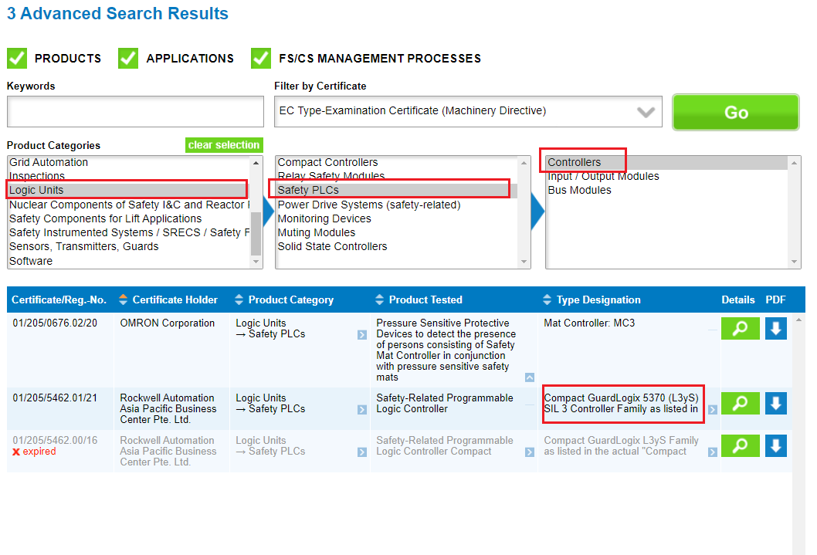
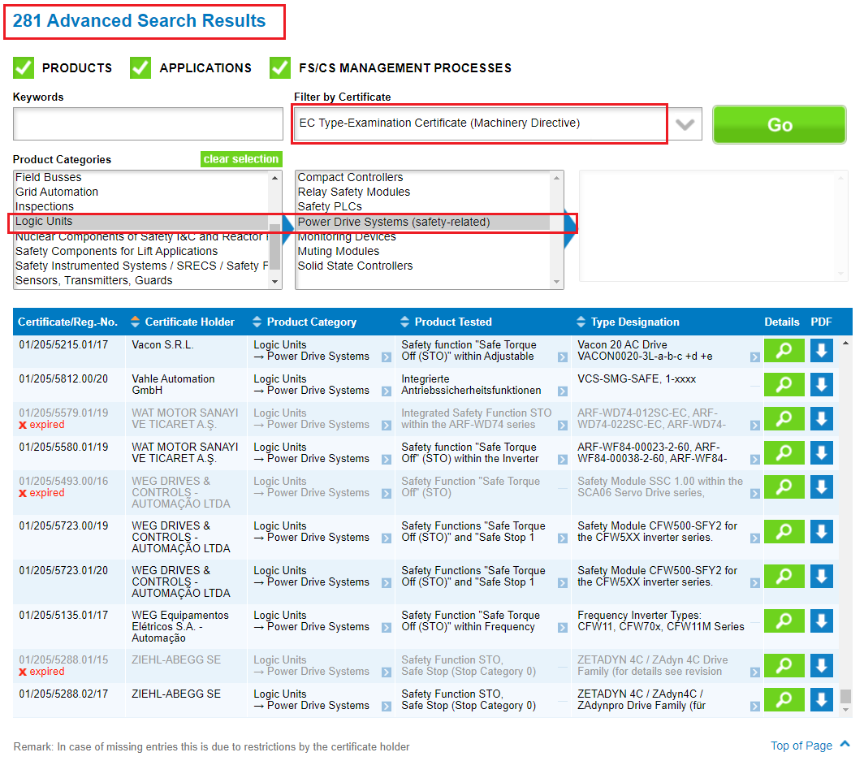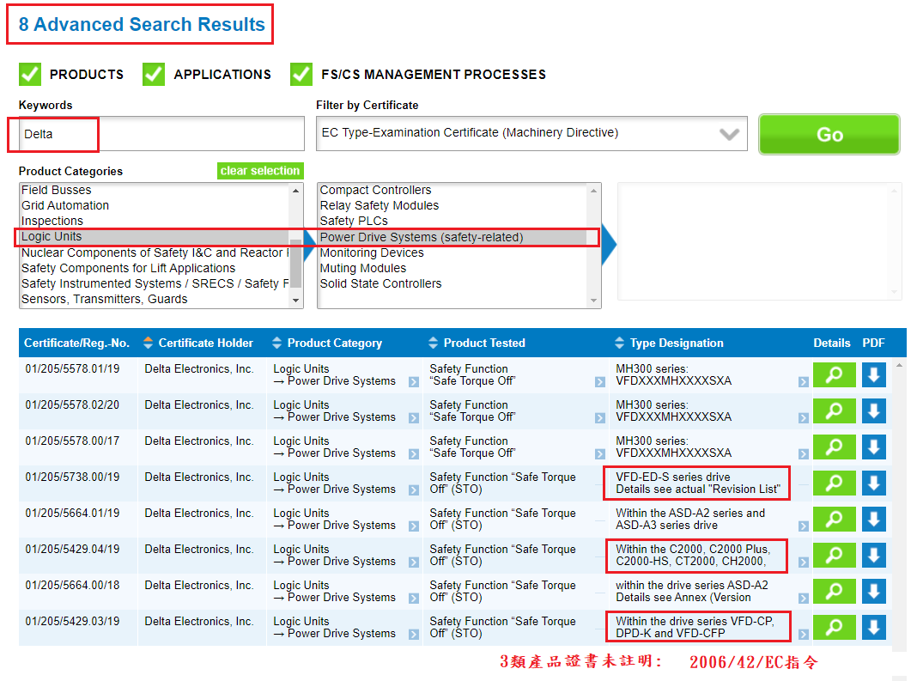TUV證書查詢結論:
- 應用於機械指令2006/42/EC 的證書, 僅限於零件Relay, Converter, safety related module, 而且僅限用於EN81,並無lift truck 或 forklift 等應用的EN1175-1及EN280最終產品驗證, Lift最終成品為非機械指令產品
- Logic Units查詢結果
a. Safety PLc(只有3家): 無48V ac相關產品應用於lift truck產品上
b. Power Drive System(281家): 大部分應用於高壓(我無法查出48V ac相關產品應用)
- 猜測報價高昂原因:
a. TUV萊茵尚未有機械指令2006/42/EC的lift truck或 forklift最終產品驗證經驗
b. 指令或安全標準要求未明確,導致執行機械指令2006/42/EC的ISO 13849-1真的需參照許多規範,或
c. 貿易障礙

